Evaluation Criteria

Connor Cuffe

Beaumaris Secondary College

Table of Contents

Evaluation Criteria 3

Cost 3

Security 3

Reliability 3

Scalability 3

User experience 3

Functionality 3

User interface Mockup 4

Mockup 1 4

Evaluation 4

Mockup 2 5

Evaluation 5

Mockup 3 6

Evaluation 7

Final Decision 7

# Evaluation Criteria

## Cost

* Zero cost for the life time of the product on both the user and developer ends.

## Security

* No evident major security flaws
  + A major security flaw is a flaw that would allow for the exposure of personal information or the impersonation of users.
* Less than five minor security flaws
  + A minor security flaw is a flaw that allows for the deletion of user data or the override of admin settings.

## Reliability

* Less than two software failures per 24 hours of use.
  + A software failure is defined as an unintended outcome that negatively affects the user experience.

## Scalability

* Can handle up to 100 users on one network with only minor performance losses.

## User experience

* Takes less than half an hour to learn the user interface.
* Timely delivery of messages received less than 1 day after sent

## Functionality

* Meets all of the functional requirements (as listed below).
  + Send messages
  + Receive messages
  + Secure accounts
  + End to end encryption
* Meets at least half of the non-functional requirements (as listed below).
  + Intuitive graphic user interface (GUI)
  + Cross platform
  + Low cost
  + Contact reason validation
  + Message reporting
  + Add extra information to displayed user profile
  + Network moderation
  + Account types

# User interface Mockup

## Mockup 1

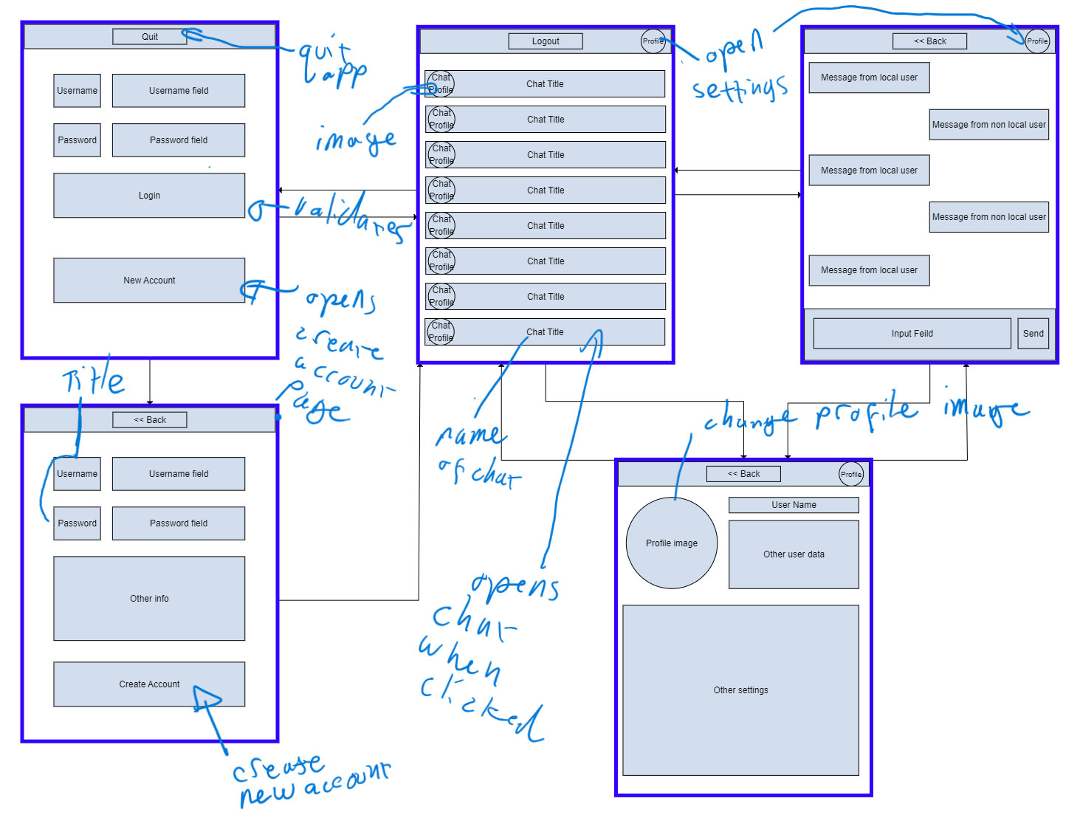

### Evaluation

#### Pros

* Similar to other messaging apps
  + Therefore, easy for users to migrate to.
* Lots of screen space for both the chat select and message screens

#### Cons

Require a large amount of button clicks to get to messages.

## Mockup 2

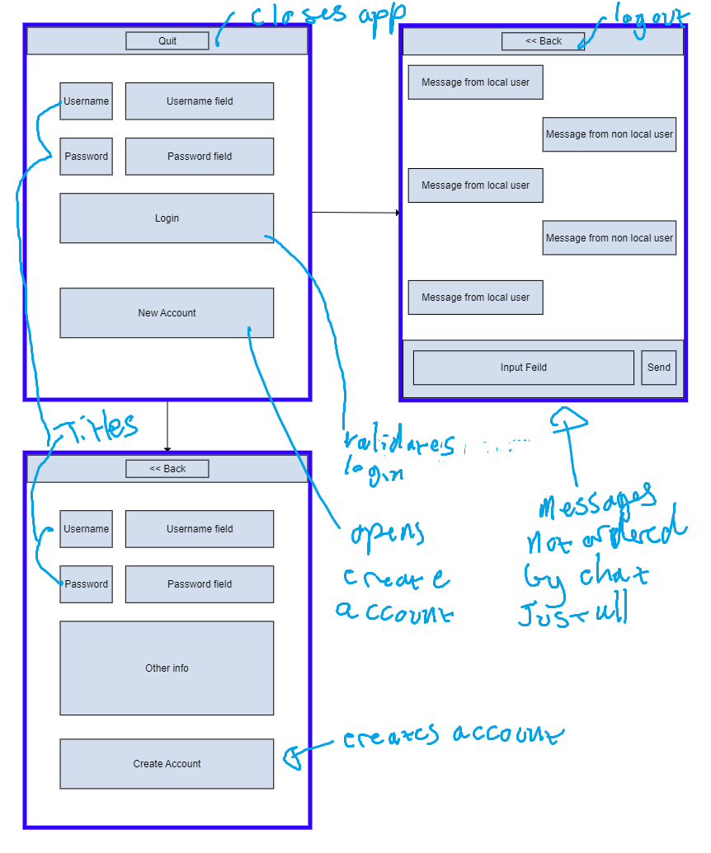

### Evaluation

#### Pros

* Simple interface small number of button clicks to get to messages

#### Cons

* Hard to read message - jumbled

## Mockup 3

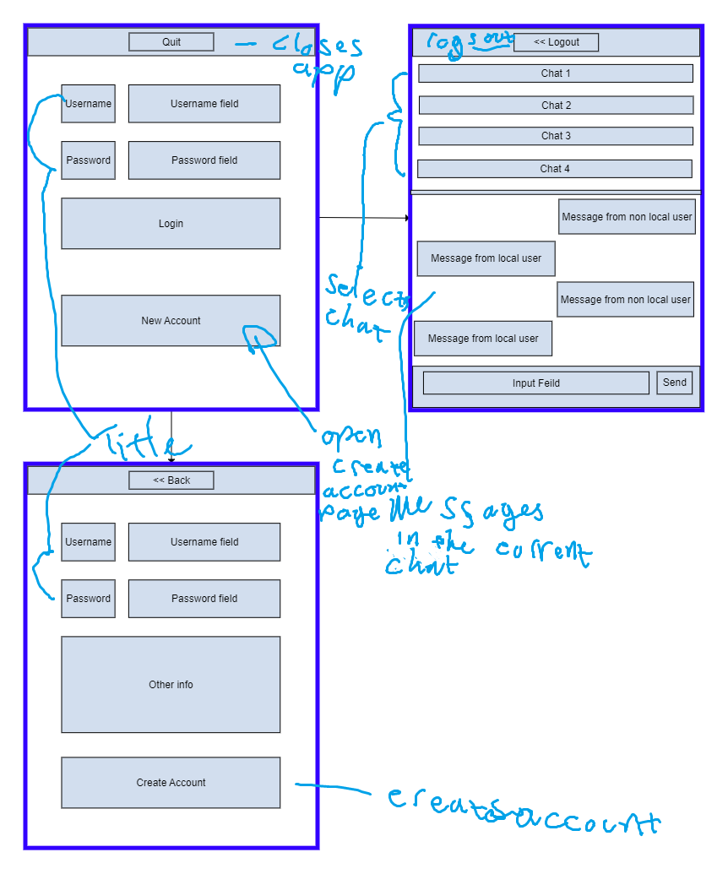

### Evaluation

#### Pros

* can easily switch between chats with few button clicks

#### Cons

* limited space for both the chat select and message screens resulting in it being hard to read.

## Final Decision

In conclusion based on the evaluation criteria identified from the data collection and analysis the first mockup has been identified as the best. This is due to it not only being easy to learn and navigate due to its similarity to other messaging apps but it also allows for the chat message screen to be neatly organized unlike mockup 2 which just shows all chat messages on one screen, resulting in it being confusing and hard to understand. Mockup 1 also gives a larger amount of screen space to the chat select and message screens unlike mockup 2 which combines them both. This additional space seems more convenient as it allows the user to quickly switch between chats however this would prove ineffective as the reduced screen space results in less chats / messages being visible, inconveniencing the user more than if the two screens were simply separated.